1. Introduction
1.1 Overview
To create a social media for our Institution
1.2 purpose
To reach the students with the invitation
2. problem definition and design thinking
- Empathy
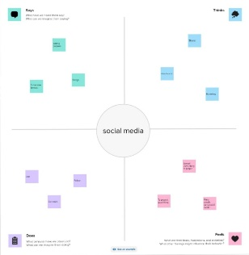

- Brainstorm

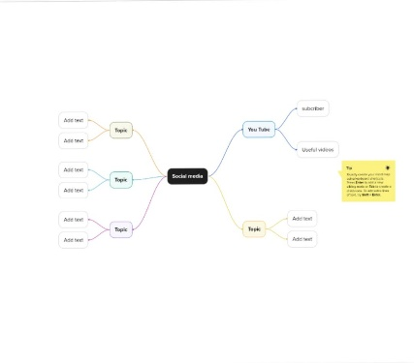
3. Result

4. Advantages and disadvantage
Its easy to reach the people at any time
It's was so easy
5. Applications
It can gather all people
6. Conclusion
Successfully created social media using the canva app

